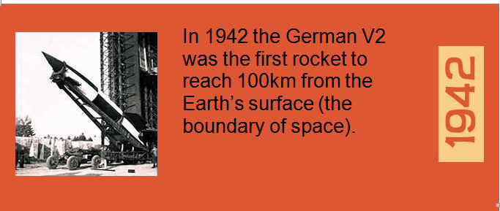

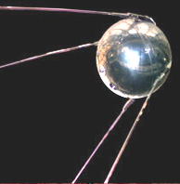 | Russia launched Sputnik 1 on October 4th, 1957; this was the first satellite that went into space. Today there are over 500 working satellites in space.

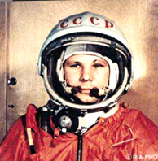 | On 12th April 1961, Russian Cosmonaut Yuri Gagarin became the first man in space. Gagarin had to land using his parachute, because the Vostok 1 was designed to crash land!

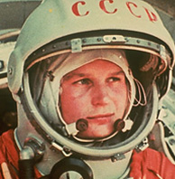 | The first woman in space was Russian cosmonaut Valentina Tereshkova. A crater on the far side of the Moon is named after her!

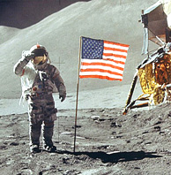 | On 20th July 1969, Neil Armstrong, and then Buzz Aldrin took "one small step" and became the first men on the moon. Their spaceship was Apollo 11.

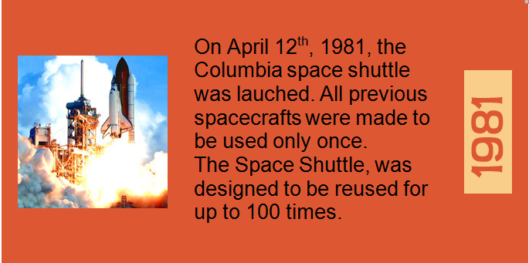

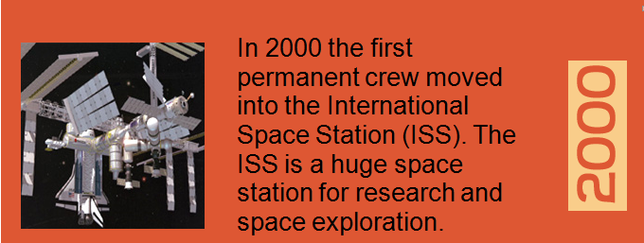

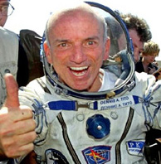 | On the 28th April 2001 American millionaire Dennis Tito became the first space tourist when he paid around 20 million dollars for a ride in a Russian spacecraft.  A new Airline, Virgin Galactic has been set up to offer private tourist flights into space.

