

**Scholars Snack Mix**

**Name_______________**

**Recipe for Scholars Snack Mix**:

½ cup of cheerios

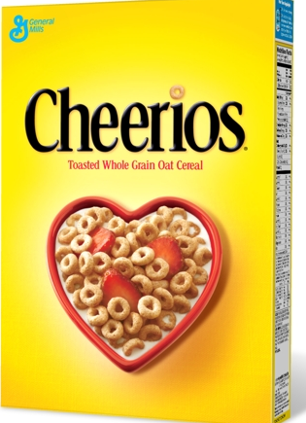

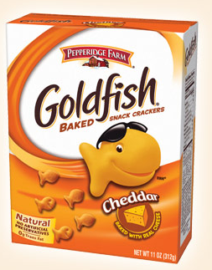

**2/3** cup of goldfish

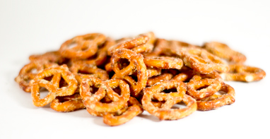

¼ cup of raisins

¾ cup of pretzels

**STEP ONE:** Measure all your ingredients into a bowl**.**

**STEP TWO:** List the ingredients in order from the one that you have the least of to the one that you have the greatest amount of**.** You need to prove your answer by making equivalent fractions so that all the ingredients have the same denominator.

=

=

 =

 =

**STEP THREE**: There are 2cups of snacks in a recipe of **Scholars Snack Mix**. How do you write 2as an improper fraction?