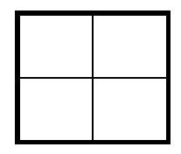
Create a Punnett square to show the possibilities of eye shape that would result if two creatures had children.

A. List the possible genotypes and phenotypes for their children.

B. What are the chances of a child with triangle eyes? ____ out of ____ or ____%
C. What are the chances of a child with star eyes? ____ out of ____ or ____%

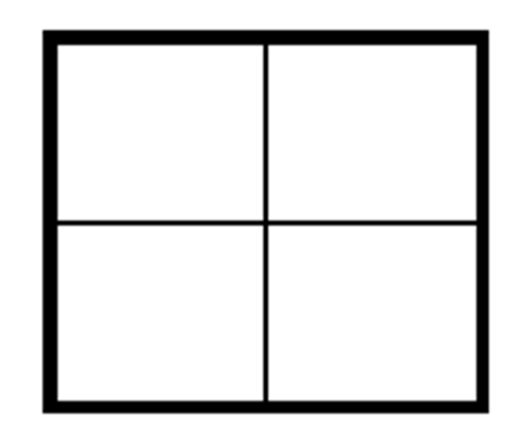
Create a Punnett square to show the possibilities of number of eyes that would result if two creatures had children.

A. List the possible genotypes and phenotypes for their children.

B. What are the chances of a child with one eye? ____ out of ____ or ____%
C. What are the chances of a child with three eyes? ____ out of ____ or ____%

