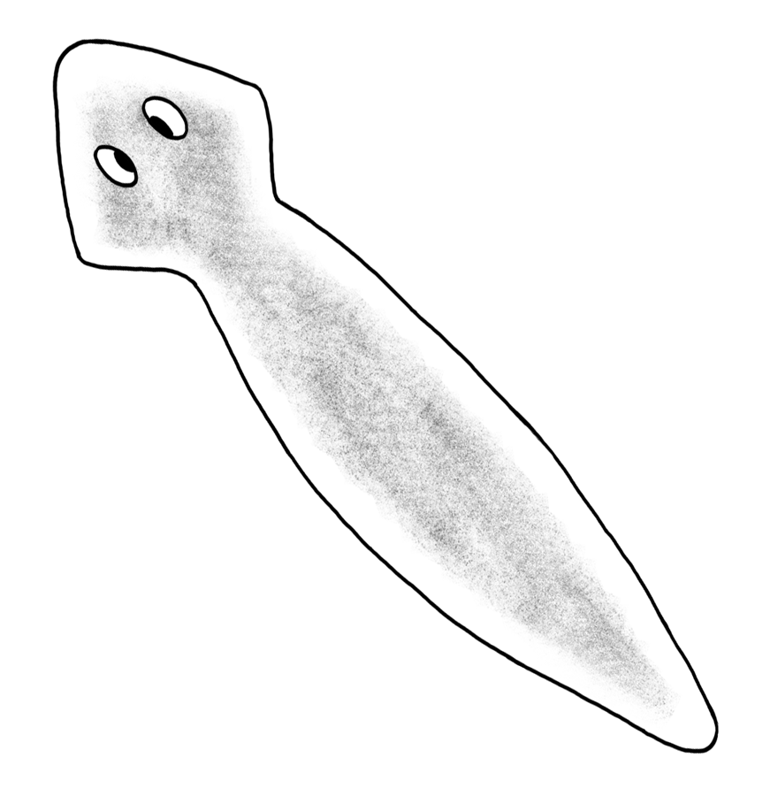

Planarian Behavior
NAME ______________________________
In today’s lab, we will observe the behavior of planarians. Planarians are also called flatworms. They are simply organisms that have an eyespot and can detect light and dark. They also can sense chemicals like food. Let’s do an activity and see what planarians do. Your instructors have placed containers in the room with 6 planarians in each.
Initial Observations
- Below, describe how the planarians are spaced in the container. Are they close together or spread out? You can draw a picture of where the planaria are located in the container.

EXPERIMENT One: A Little Shade
Now, cover ½ of the container with a piece of black paper. We will wait a few minutes and see how the planarians respond when provided shade.
- Next to the word ‘hypothesis,’ write down what you think will happen to the planarians. Where will they go? Why?
Hypothesis –

- Observations after 5 minutes: As before, write down where the planarians are. Did they stay in the light or move into the dark? How many moved? It is fine to draw a picture to help in your description.

EXPERIMENT TWO: A Little Food
OK, after you have finished recording the position of the planarians, add a small piece of liver to the side of the container that was not covered by the dark paper (the light side).
- What do you expect to happen now? Will the planarians move? Write down your prediction by the word ‘hypothesis’ below.
Hypothesis –
- Now, observe the planarians after 5 minutes. Again, record their position and use a drawing to aid in your description of where they are.

- Why do you think they responded to the liver in this way?

CONCLUSIONS
- Do you think their responses to the dark and liver are instinct or learned? Why?

