Number Line Fractions
STEP ONE: Draw a line in the middle of your number line. Put in the arrow signs. Put a 0 on the left side and a 1 on the right side.
1
0

STEP TWO: Fold your number line in half. Mark ½ and 2/2.
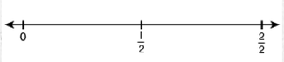
STEP THREE: The number line is 24 inches long. If you want to mark 1/3, you need to measure ___ inches. If you want to find 2/3, you need to measure ___ inches. Put in 1/3, 2/3 and 3/3 on your number line.
0
STEP FOUR: Fold your number line in half two times. You should now have four parts. Mark ¼, 2/4, ¾, and 4/4.
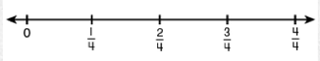
STEP FIVE: Fold your number line in half three times. You should now have ____ sections.
Mark 1/8, 2/8, 3/8, 4/8, 5/8, 6/8, 7/8, 8/8.
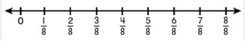
- What fraction is equivalent to ¾?______
- Put the correct sign in the blank (< or >). 7/8 ___ 2/3
- Put these fractions in order from least to greatest: ¾, 5/8, ½, 2/3
- Name two fractions that are greater than 8/12.

