

Clothes

Jeans $39.99

T‐shirt $9.99

**GOING SHOPPING**

Candy

.99

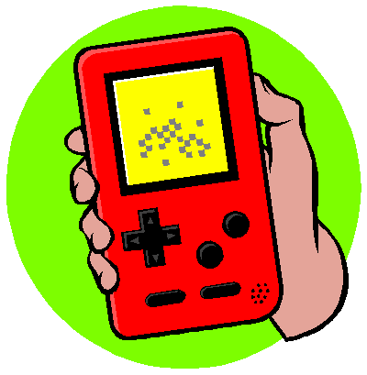

Purse

$9.99

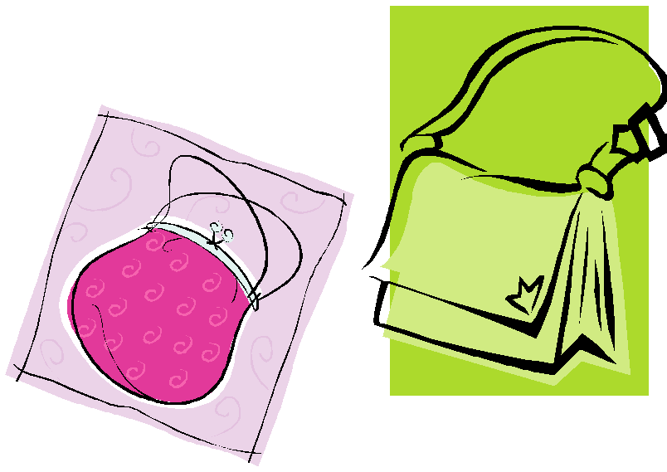

PSP $169.99

Nintendo DS $129



Movie

$6.00

Popcorn Package

$5.50

Chips

$1.29



iTunes

$9.99

10 songs





Bike: $89.99

$89.99



Wireless Control: $39.99

Video Game:

$27.99



Pizza

Large $11.99

Medium $8.99

Small $5.99