Directions: Use at least one of each color patch to make your quilt square. Measure all your pieces in inches .
Size of Patch | Number of Patches | Area of one patch | Total Area of all patches of this size | Perimeter of one patch | Total Perimeter of all patches of this size
Small
white
Medium
yellow
Large
blue
Extra Large
pink
- What is the area of the whole quilt square?_______________
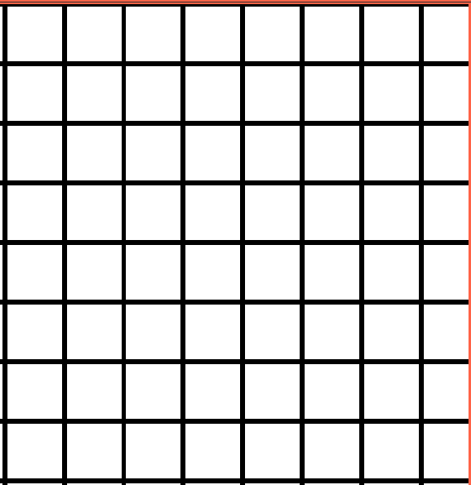
- What do you get when you add up the total area of all the patches?_____
- What is the perimeter of the whole quilt square?__________
- What do you get when you add up the perimeter of all the patches?______

