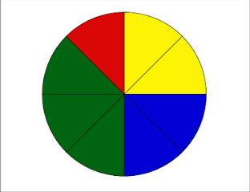
Name___________________________

Step One: Spin the spinner TEN times and record your results below.
 | Number of times landing on this Color | Total number of spins | Probability  of landing on this color
Red
Yellow
Blue
Green
Step Two: Record the class’ 100 trials in the chart below .
 | Number of times landing on this Color | Total number of spins | Probability  of landing on this color
Red
Yellow
Blue
Green
Step Three: Use the data from Step two to answer the questions below.
- If we were to spin the spinner 200 times, how many times would we expect to land on blue?

- If we were to spin the spinner 50 times, how many times would we expect to land on green?

- If we were to spin the spinner 150 times, how many times would we expect to land on red?

Step Four: A group of 5th graders were surveyed about their favorite food. The results are recorded below.
Favorite Food | Number of Students
Hot Dogs | 24
Hamburgers | 18
Pizza | 21
Chicken Nuggets | 12
- If 25 more students were surveyed:

  - How many would you expect to choose hot dogs?

  - How many would you expect to choose hamburgers

- BONUS: If 50 more students were surveyed, how many would you expect to choose pizza?

