You will read a weather map and
create your own weather report.

- Fill in the blanks on the
My Weather Report page using the
weather map. At the end, use the
information on the map to write your own
complete sentence about something you
see on the map.

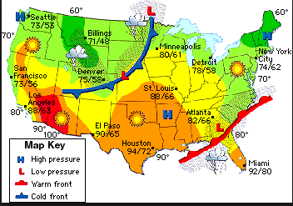

Explore!

You will follow the directions to create a weather map for Nevada.

- Draw a cold front that is headed from Carson City towards
Las Vegas.
- Draw a symbol to show there is Low Pressure near the cold front.
- Draw a circle to put the high and low temperature in.
- Show that the high temperature for Las Vegas is 80 degrees.
- Show that the low temperature for Las Vegas is 65 degrees.

Weather Station 3:
Task Cards!

Record your answers to the eight cards on your recording sheet. Answer question number seven in complete sentences.

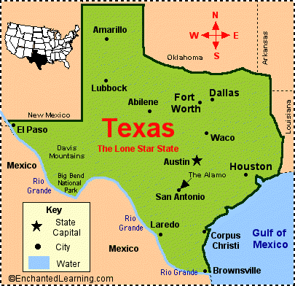

Weather Station 4:
Chart It!

You will follow the directions to create a chart about warm and cold fronts

- Draw the symbols for cold and warm front with colored pencils.
- Glue the correct description for warm and cold front.
- Read: What are Weather Fronts?
- Describe the weather that comes with a cold and warm front.
- Use colored pencils and cotton balls to create a picture of what a warm and cold front would look like.

