STATION ONE: READING A WEATHER MAP

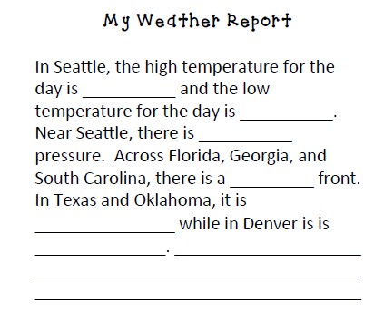
STATION TWO: MAKING A WEATHER MAP
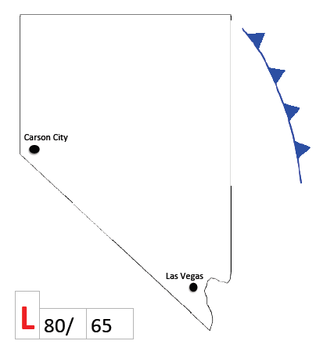
STATION THREE: WEATHER TASK CARDS
1. | 2. | 3.
4. | 5. | 6.
7. | 8.

STATION FOUR: CHART OF WARM AND COLD FRONTS
Name | Weather Symbol | How does this front form? | What kind of weather does it bring? | What does the sky look like during this kind of front?
Cold Front
Warm Front

