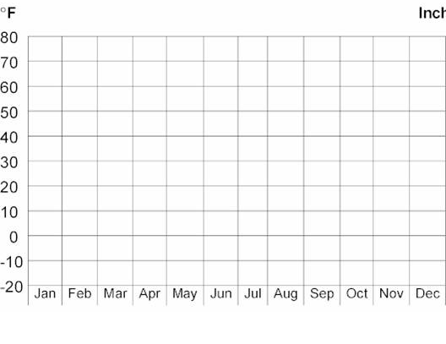
Average Monthly Temperature of ___________________________
Directions:

- Graph the mean (average) monthly temperature for each month.

- What factors: latitude (distance from the equator), closeness to the ocean, elevation (distance above sea level), and closeness to mountains most influence the climate of this city?
___________________________________________________________________.

- What is the total precipitation for the year in this city?_______________.

- Describe the climate of this city (overall temperature of the city, overall amount of precipitation)_______________________________________________________.

