Directions for Making a Model of the Layers of the Earth
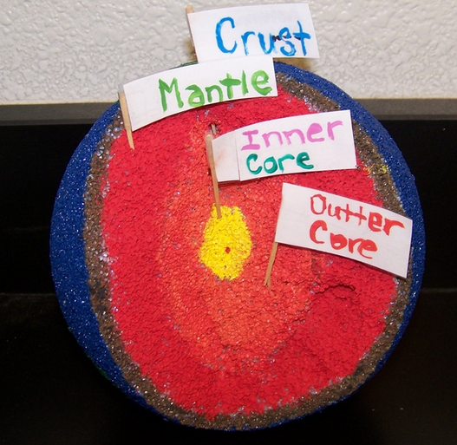
- You will use markers to color in the four layers of the Earth. Pay attention to the size of each layer using the diagram on your worksheet.
  - Crust- color brown
  - Mantle- color red
  - Outer Core- color orange
  - Inner Core-color yellow
- Color the outside of your earth: blue for the water and green for the land. Remember, the earth is 70% water.
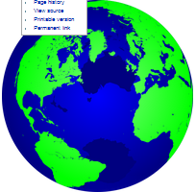
- You have four toothpicks labeled with the layers of the earth. Place the toothpicks in the correct location.

