**Area, Perimeter and Folding Parallelograms Name**

Begin with a square sheet of paper.

1. To create the *valley folds, fold each of the following, unfolding again after each fold.* 
   1. *Down the center along the vertical line of symmetry.*
   2. *Diagonally, from vertex to vertex, along the two diagonal lines of symmetry.*
   3. *From each upper vertex to the center point O.*

A

C

D

E

F

G

H

B

K

O

J

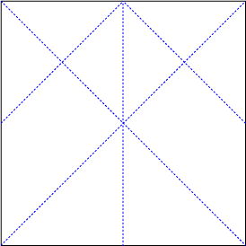

1. The original square shown above had a side of length 4 inches. Use that information and the Pythagorean Theorem to determine the lengths of all the dotted line segments. Label the diagram with the lengths, as appropriate.
2. Take your square sheet of paper, and fold the upper vertices down to the center, making the pentagon below. Use the segment lengths from #2 to calculate the area and the perimeter of this pentagon.

Area

Perimeter

1. Next, fold the pentagon in half, along the center line, producing a trapezoid pictured below. Use the segment lengths from #2 to calculate the area and the perimeter of this trapezoid.



Area

Perimeter

1. Next, fold the trapezoid along the longer fold line, resulting in folding the larger triangle up so the vertices meet. This should produce a parallelogram, as shown below. Use the segment lengths from #2 to calculate the area and the perimeter of the parallelogram.



Area

Perimeter