**Angle Measures and Folding Parallelograms Name**

Begin with a square sheet of paper.

1. To create the *valley folds, fold each of the following, unfolding again after each fold.* 
   1. *Down the center along the vertical line of symmetry.*
   2. *Diagonally, from vertex to vertex, along the two diagonal lines of symmetry.*
   3. *From each upper vertex to the center point O.*

A

C

D

E

F

G

H

B

K

O

J

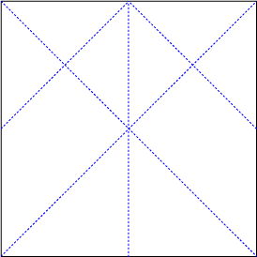

1. What is the measure of the interior angle of a square?
2. What do the diagonal folds of the square do to the interior angles of the squares? What is the measure of the new angles formed?
3. Find an obtuse angle. What is its measure? How do you know?
4. In the picture above, label each angle with its appropriate measure.

Next, take your square sheet of paper, and fold the upper vertices, back to the center point, making the shape below.



Next, fold the figure in half, along the center line, producing a trapezoid pictured below.



Next, fold the figure along the longer fold line, resulting in folding the larger triangle up so the vertices meet. This should produce a parallelogram, as shown below.

