|  |  |  |  |  |  |
| --- | --- | --- | --- | --- | --- |
| **Australia** | **Ocean** | **Savanna** | **Amazon** | **Great Plains** | **Artic** |
| **Grasses (P)** | Phytoplankton (P) | Grasses (P) | Banana Tree (P) | Buffalo Grass (P) | Moss (P) |
| **Fruit (P)** | Seaweed (P) | Acacia (P) | Bamboo (P) | Wildflower (P) | Phytoplankton (P) |
| **Kangaroo (H)** | Mantee/Sea Cow (H) | Zebra (H) | Chimpanzee (H) | Bison (H) | Krill (H) |
| **Koala (H)** | Krill (H) | Wildebeest (H) | Fruit bats (H) | Deer (H) | Artic Rabbit (H) |
| **Platypus (C)** | Clam (O) | Lion (C) | Python (C) | Skunk (O) | Lemming (H) |
| **Fierce Snake (C)** | Sea Turtle (C) | Cheetah (C) | Jaguar (C) | Coyote (C) | Caribou (H) |
| **Dingo (C)** | Sea Otter (C) | Grasshopper (H) | Toucan (O) | Foxes (C) | Polar Bear (C) |
| **Frill-Necked Lizard (C)** | Dolphin (C) | Scorpion (C) | Squirrel Monkey (O) | Barn Owl (C) | Seal (C) |
| **Freshwater Shrimp (H)** | Blue Whale (C) | Ostrich (O) | Copper Grasshopper (H) | Bull Snake (C) | Artic Cod (C) |
| **Cicada (H)** | Shark (C) | Meerkat (O) | Huntsman Spider (C) | Grasshopper (H) | Wolf (C) |

P – Producers

H – Herbivores

O – Omnivores

C – Carnivores

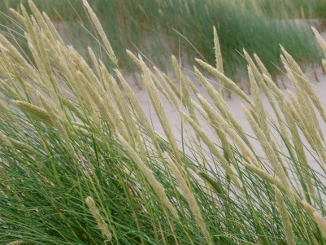 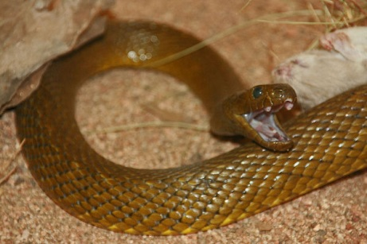

Grasses Fierce snake (Inland Taipan)

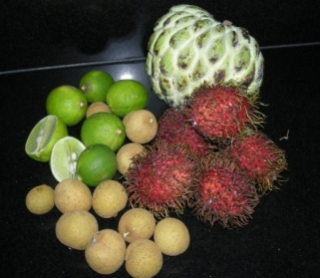 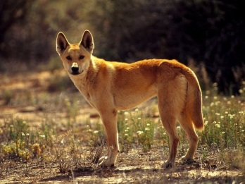

Fruit Dingo

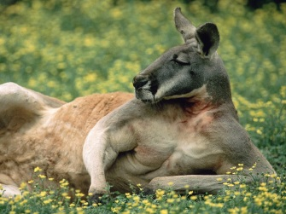 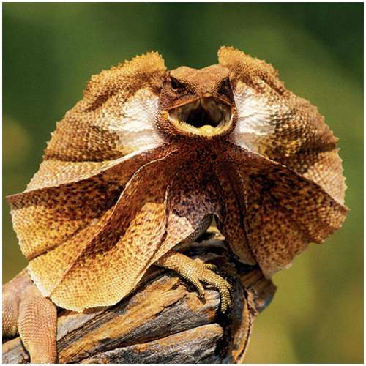

Kangaroo Frill Necked Lizard

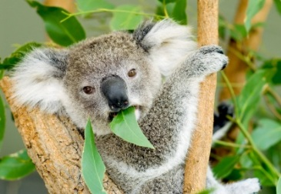 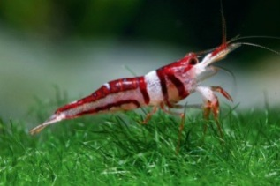

Koala bear Freshwater Shrimp

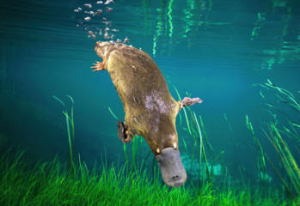 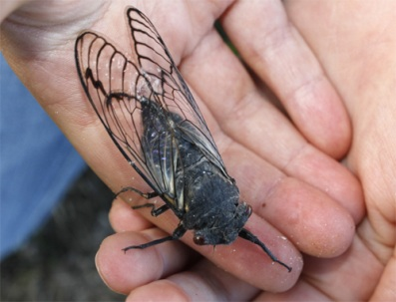

Platypus Cicada

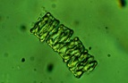 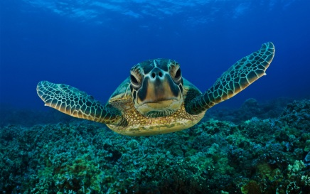

Phytoplankton Sea Turtle

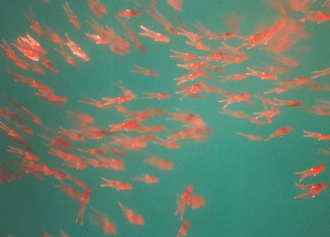 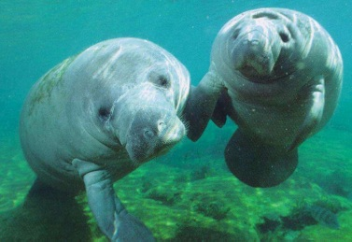

Krill Manatee

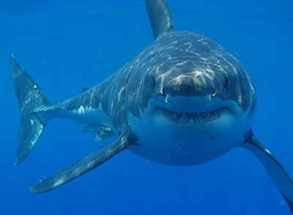 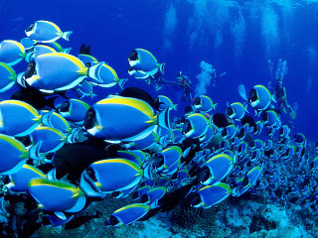

Great White Shark Fish

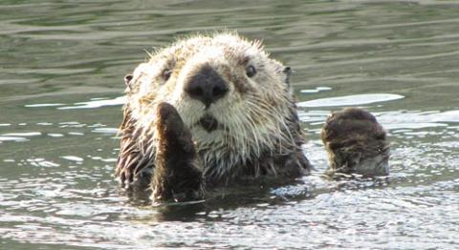 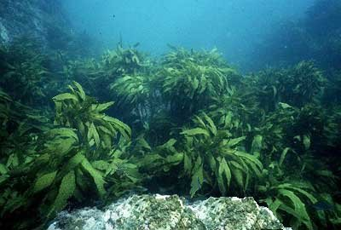

Sea Otter Sea Weed

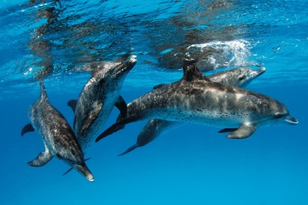 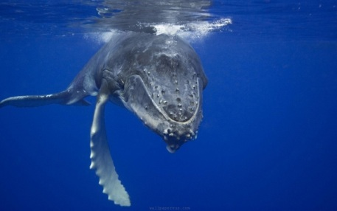

Dolphins Blue Whale

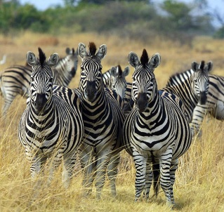 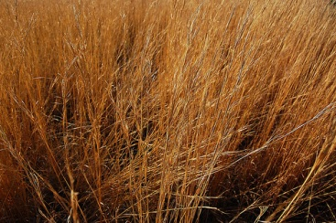

Zebra Grass

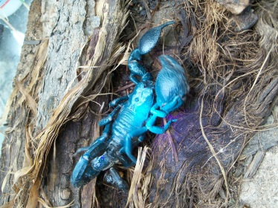 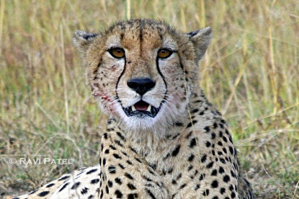

Blue Scorpion Cheetah

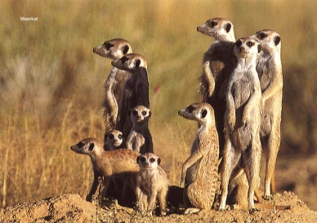 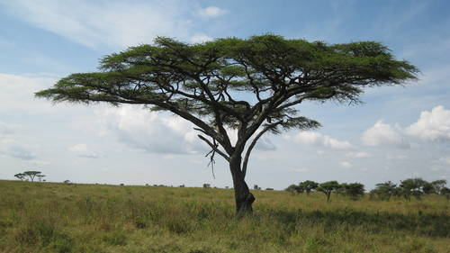

Meer Kat Acacia

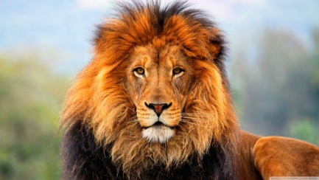 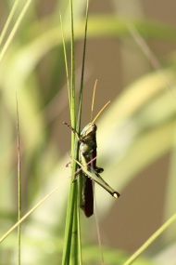

Lion Grasshopper

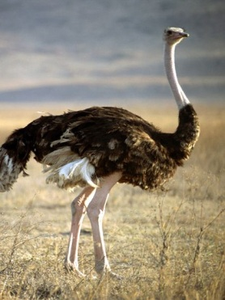 Ostrich Giraffe 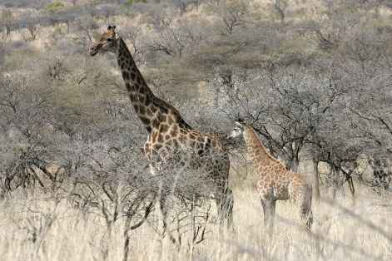

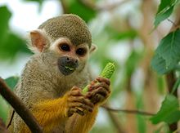 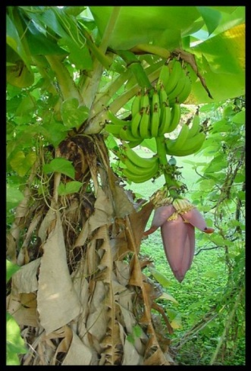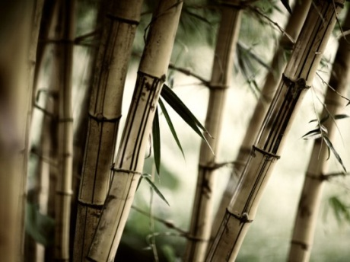 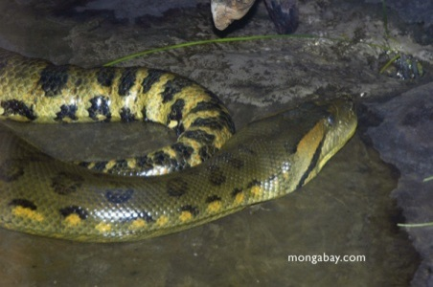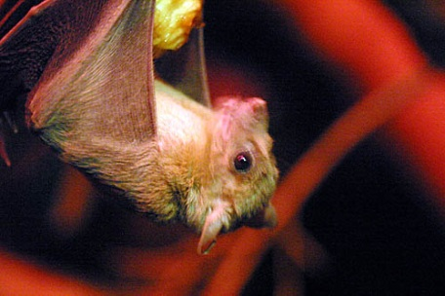 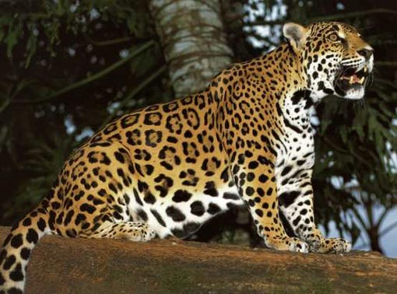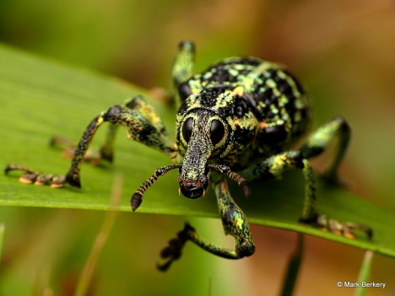 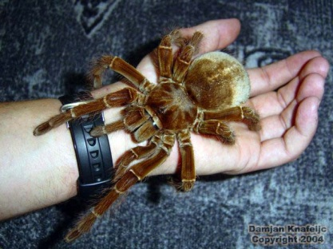

Tarantula

Beetle

Python

Jaguar

Squirrel Monkey

Bamboo

Fruit bat

Banana tree

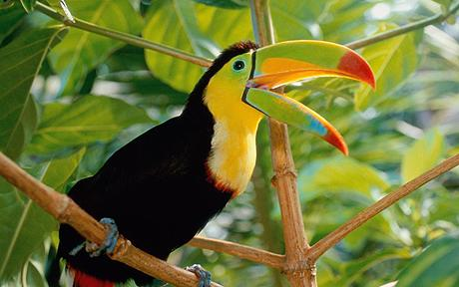 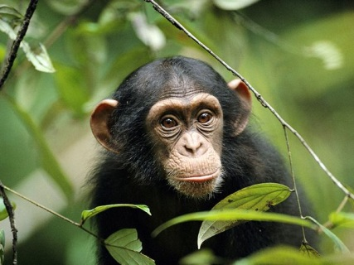

Chimpanzee

Toucan

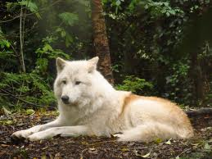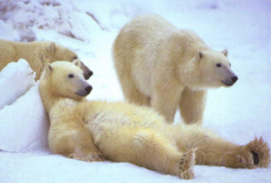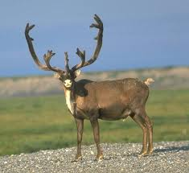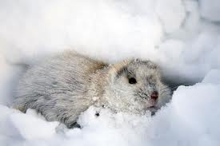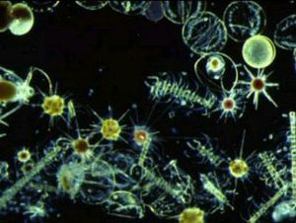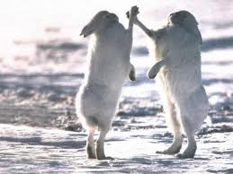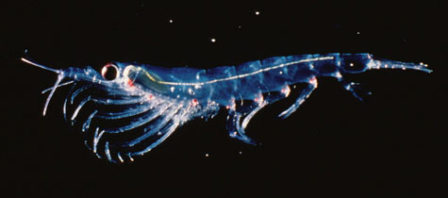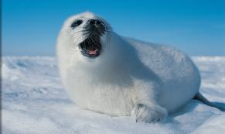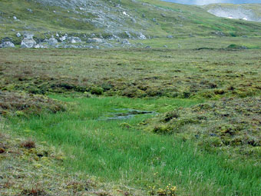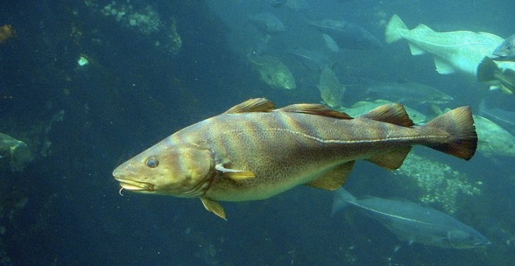

Rabbit

Seal

Krill

Grasses/Mosses

Phytoplankton

Cod Fish

Lemming

Polar bear

Caribou

Wolf

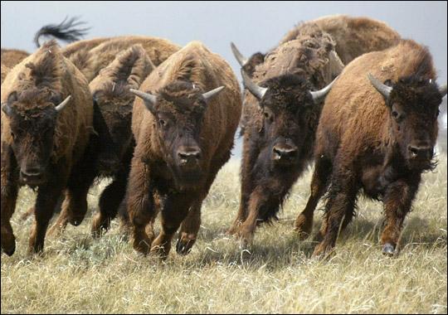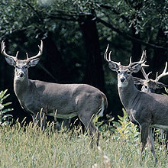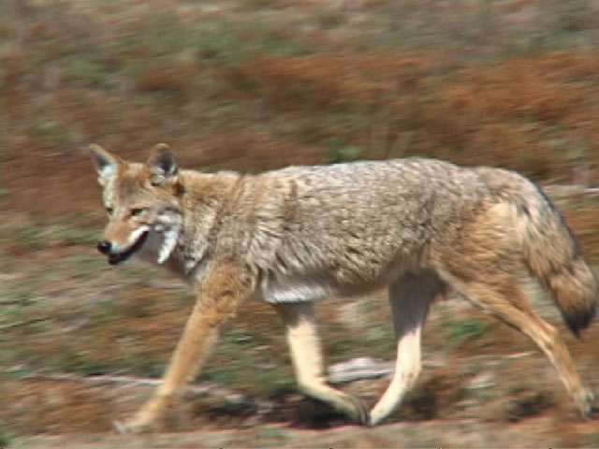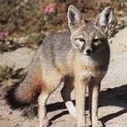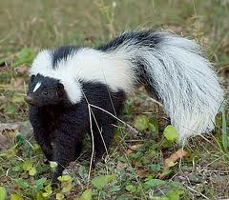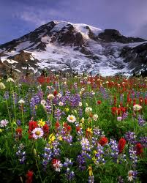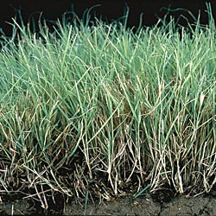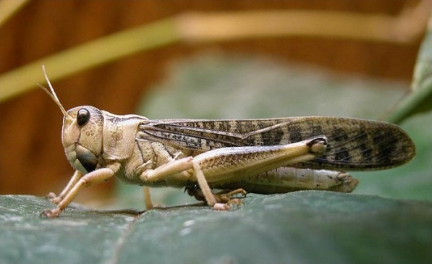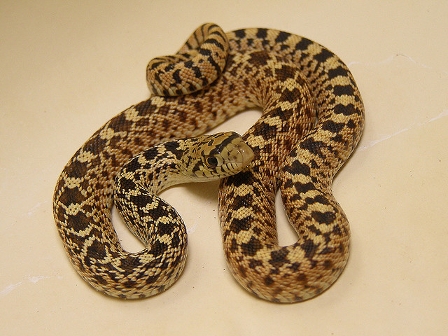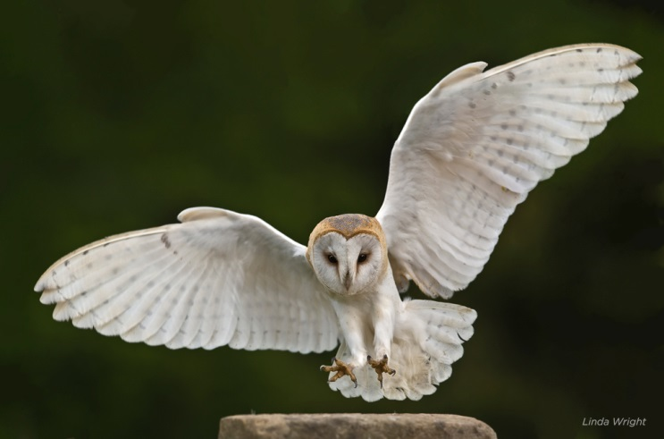

Coyote

Barn Owl

Deer

Skunk

Bull Snake

Buffalo

Fox

Buffalo Grass

Wildflowers

Grasshopper