Schedule for Math Certification Workshop

Session One: Overview and Number Concepts (1/16)
- Overview of domains and competencies on the 4-8 exam
- Use of calculators
- Website link: http://eteamscc.com/2013/math-certification/
- Vocabulary and formula chart
- Practice Problems: work in pairs
- Go over answers
- H.W. for next meeting:
  - Chapter Two: read and take quiz
  - Chapter Three: read and bring questions
  - Make flashcards of key concepts and vocabulary

Session Two: Patterns of Algebra (2/20)
- Parent Functions
- Basic Trigonometry
- Practice Problems: work in pairs
- Go over answers
- H.W. for next meeting:
  - Chapter Three: take quiz
  - Chapter Four and Six: read and bring questions
  - Make flashcards of key concepts and vocabulary

Session Three: Geometry (3/27)
- Geometry handout
- Practice Problems: work in pairs
- Go over answers
- H.W. for next meeting:
  - Chapter Four: take quiz
  - Chapter Five and Seven: read and bring questions
  - Make flashcards of key concepts and vocabulary

Session Four: Probability and Statistics (4/10)
- Practice Problems: work in pairs
- Go over answers
- H.W. for next meeting:
  - Chapter Five: Take Quiz
  - Take Practice Test I using notes
  - Review flashcards

Session Five: Putting it All Together (5/15)
- Practice Test
- Test Taking Strategies
- H.W.:
  - Take Practice Test II timed using CD
  - Call Ms. Moore if you need to set up extra practice sessions
  - Register for, take and pass the 4-8 test

Contact Information:
Kim Moore, kim.moore@tamucc.edu (361) 779-6123

Resources:
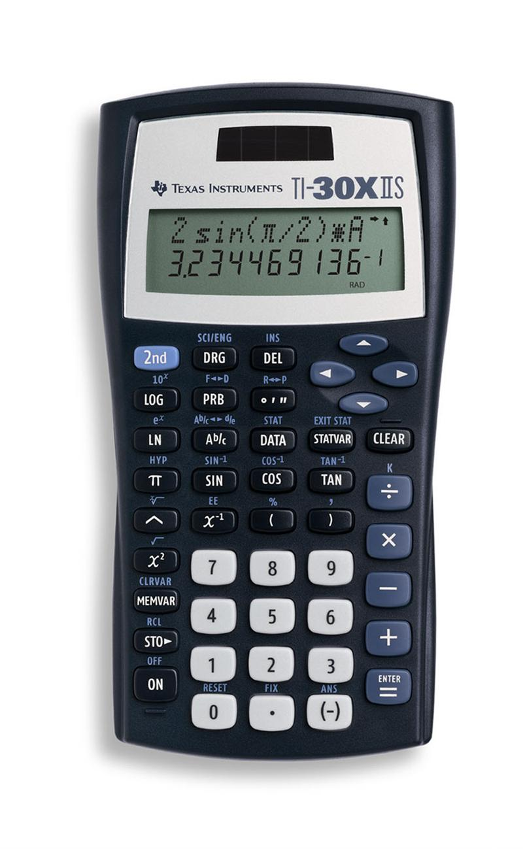
- ETS Manual Linked on website

- https://pact.tarleton.edu/tcert/ Contains modules with practice problems.

